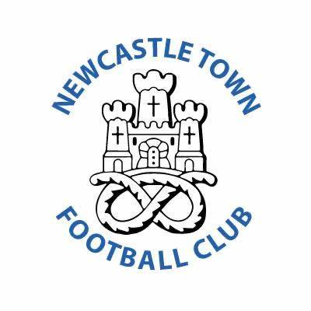

**Parent/Spectator Code of Conduct**

Parents /Spectators have a great influence on children’s enjoyment and success in football. All children play football because they first and foremost love the game – its fun. It is important to remember that however good a child is or becomes at football positive encouragement will contribute to children enjoying football.

Please aim to ensure that you are always positive and encouraging towards all the children, not just your own.

* As parents / spectators you should-
* Applaud the opposition as well as our own team.
* Avoid coaching the child during the game, this may conflict with the coaches’ instructions.
* Not shout and scream
* Respect the referee and assistant referee’s decisions.
* Give attention to each of the children involved in football not just the most talented.
* Give encouragement to everyone to participate in football.
* Adhere to the FA Respect programme.
* Remember that children play for FUN.
* Applaud effort and good play as well as success.
* Respect the Referee’s decisions even when you don’t agree with them.
* Appreciate good play from whatever team it comes from
* Remain behind the touchline and within the Designated Spectators’ Area
* Let the coach do their job and not confuse the players by telling them what to do!
* Encourage the players to respect the opposition, referee and match officials.
* Support positively and offer players encouragement not criticism
* Never engage in, or tolerate offensive, insulting or abusive language or behaviour

**I understand that if I do not follow the Code, any/all the following actions may be taken:**

**I MAY BE:**

* Issued with a verbal warning from a club or league official
* Required to meet with the club, league or CFA Welfare Officer
* Required to meet with the club committee.
* Obliged to undertake an FA education course.
* Obliged to leave the match venue by the club.
* Requested by the club not to attend future games.
* Suspended or have my club membership removed.
* Required to leave the club along with any dependents.

**IN ADDITION:**

* The FA/County FA could impose a fine and/or suspension on the club. We all bear a collective responsibility to set a good example and help provide a positive environment in which children can learn and enjoy the game. Play your part and always observe The FA’s Respect Code of Conduct for spectators.