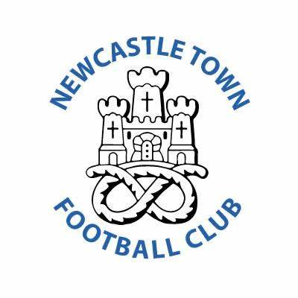

**Code of Conduct for Players**

Players are the most important people in the sport. Playing for the team, and the team to win, is the most fundamental part of the game, but winning at any cost, fair play and respect for all others in the game is fundamentally important. The key concepts in this code are valid for players at all levels.

**A player should-**

* Make every effort to develop their own sporting abilities, in terms of skill, technique, tactics & stamina.
* Give maximum effort and strive for the best possible performance during a game, even if his team is in a position where the desired result has already been achieved.
* Set a positive example for others, particularly young players and supporters.
* Avoid all forms of gamesmanship and time-wasting.
* Always have regard for the best interests of the game, including where publicly expressing an opinion on the game & any aspect of it, including others involved in the game.
* Not use inappropriate language.
* Make every effort consistent with Fair Play & the Laws of the Game to help own team win.
* Resist any influence which might, or might be seen to, bring into question his commitment to the team winning.
* Know and abide by the Laws, rules and spirit of the game, and the competition rules.
* Accept success and failure, victory and defeat, equally.
* Resist any temptation to take banned substances or use banned techniques.
* Treat opponents with due respect at all times, irrespective of the result of the game.
* Safeguard the fitness of opponents, avoid violence, rough play & help injured opponents.
* Accept the decision of the Match official without protest.
* Avoid words or actions which may mislead a Match Official.
* Show due respect towards the Match officials.
* Abide by the instructions of their Coach & Match Officials, provided they do not contradict the spirit of this code.
* Show due respect towards the Team Officials of the opposition.
* Show due respect to the interests of supporters.

I understand that if I do not follow the code, any/all of the following actions may be taken by my club, county FA or The FA:

**I MAY:**

* Be required to apologise to my team-mates, the other team, referee or team manager.
* Receive a formal warning from the coach or the club committee.
* Be dropped or substituted.
* Be suspended from training.
* Be required to leave the club.

**IN ADDITION:**

• My club, County FA or The FA may make my parent or carer aware of any infringements of the Code of Conduct

• The FA/County FA could impose a fine and suspension against my club.